API Integration Report

I have got data from provided following API Link, and copy data from browser.

(<https://sanity-nextjs-application.vercel.app/api/hackathon/template7>)

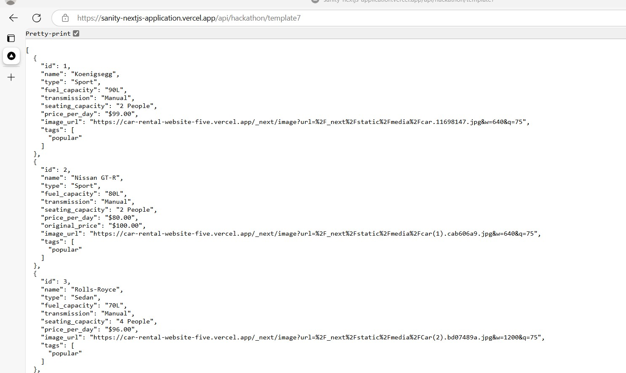

And I provide to chatgpt : to import data in sanity chatgpt provide code for data migration.

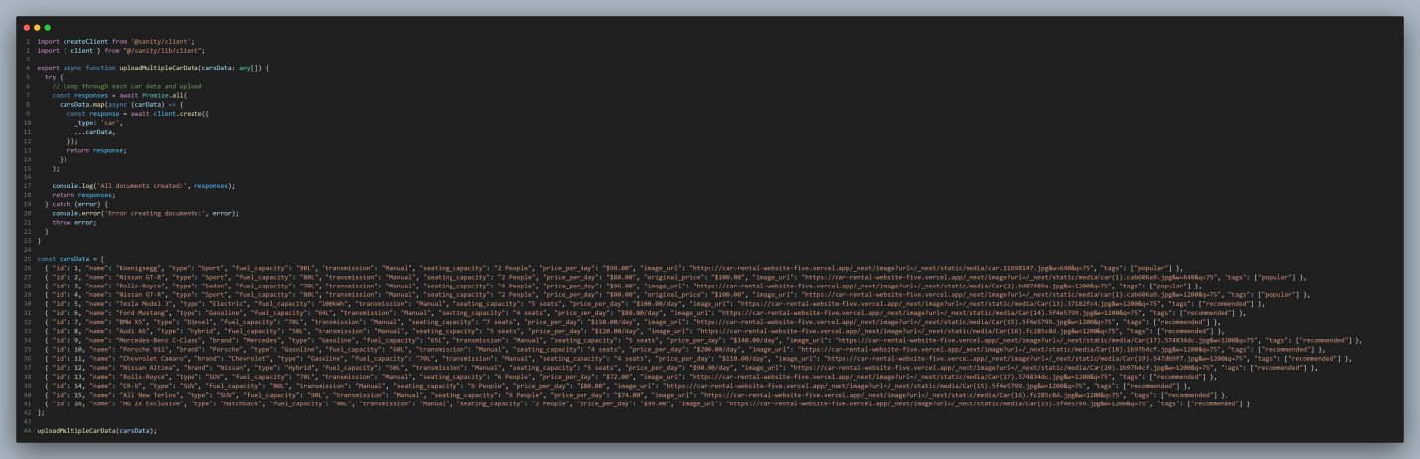

So, I am crate a new file with name. **impdatacar.ts** separately at root directory. Finally I compile with **tsc impdatacar.ts** and execute with **node impdatacar.ts** than I migrate my data in sanity.

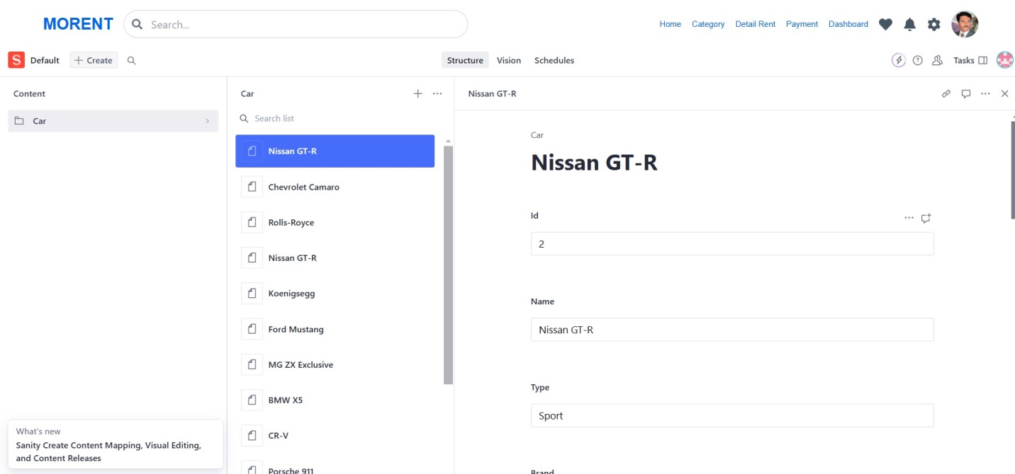

Populate data from sanity to my frontend with a following function.

async function getdata(qr:any){

  const fetchData = await client.fetch(qr)

    return fetchData

 }

And get data in different grop query

 const data= await getdata(`*[_type == 'car' && id ==2]`)

    const datap= await getdata(`*[_type == 'car' && tags match '*popular*' ] | order(id asc) `)

    const datar= await getdata(`*[_type == 'car' && tags match '*recommended*' ] `)

display in my component.

  {/* Popular component car start */}

          {datap.map((val: any, i: any) => (

            <div key={val.id} className="bg-white w-[304px] h-[380px] rounded-[10px] ml-16">

              <h1 className="font-jakarta text-[20px] text-car_name_color w-[150px] h-[24px] p-2">

                {val.name}

              </h1>

              {val.likecar ? (

                <p className="box" id="text-1">

                  <FaHeart className="text-like_color ml-[258px]" />

                </p>

              ) : (

                <FaRegHeart className="text-type_ticon ml-[258px]" />

              )}

              <h1 className="font-jakarta text-[16px] text-type_ticon w-[128] h-[20px] px-2">

                {val.type} {val.id}

              </h1>

              <div className="w-[260px] h-[100px] ml-[25px] mt-[90px] flex place-items-end justify-center text-sm">

                <Image

                  src={val.image_local}

                  width={600}

                  height={600}

                  className="w-[305px] h-[160px] drop-shadow-xl"

                  alt="Popular Car"

                />

              </div>

**Data successfully displayed in the frontend.**

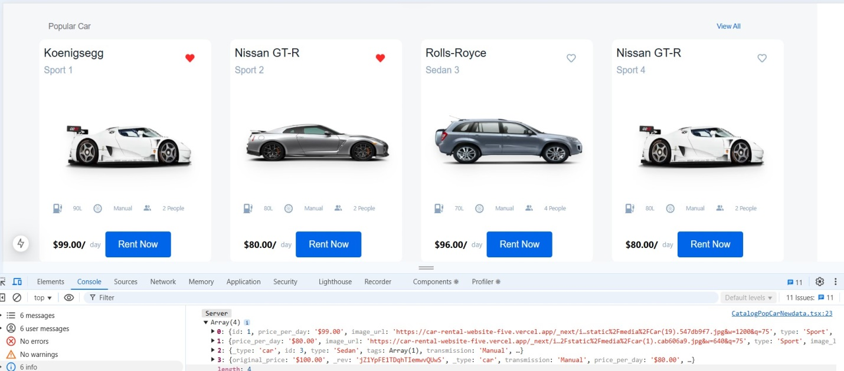

I am display my data in console grouq query. Only popular cars.